ACTIVITY 1

# **SWACHH BHARAT**

**Swachh Bharat Abhiyan – Clean India Drive**

1. **Introduction**

*"Sanitation is more important than independence."* – *Mahatma Gandhi*

Swachh Bharat Abhiyan, or the Clean India Mission, is a historic cleanliness campaign launched by the Government of India on 2nd October 2014 to honor the birth anniversary of Mahatma Gandhi, the father of our nation. This nationwide movement aims to improve sanitation and hygiene, eradicate open defecation, and promote solid waste management practices.

The mission also emphasizes behavior change through public participation and awareness campaigns. The initiative has witnessed participation from government bodies, NGOs, educational institutions, and citizens alike. As responsible youth, it is our duty to contribute to this noble cause that directly affects public health and the environment.

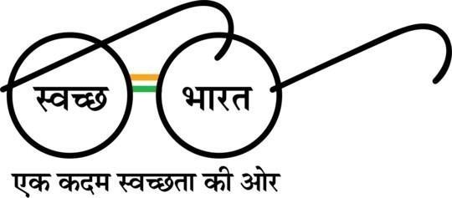

## **Objective of the Activity**

The primary objectives of this drive were:

• To promote awareness regarding cleanliness and hygiene among students.

• To involve youth in nation-building through community work.

• To inculcate responsibility for maintaining clean surroundings.

• To support the goals of the Swachh Bharat Abhiyan at a grassroots level.

1. **Description of the Activity**

The Swachh Bharat cleanliness drive was conducted as a collaborative event involving students from various colleges. The activity took place on the school premises where students volunteered to clean classrooms, school grounds, and surrounding areas.

The event started at 8:30 AM with all participants gathering at the entrance of the school. We were addressed by coordinators and briefed about the cleanliness mission. The participants were then grouped and assigned specific zones to clean, ensuring systematic coverage of the premises.

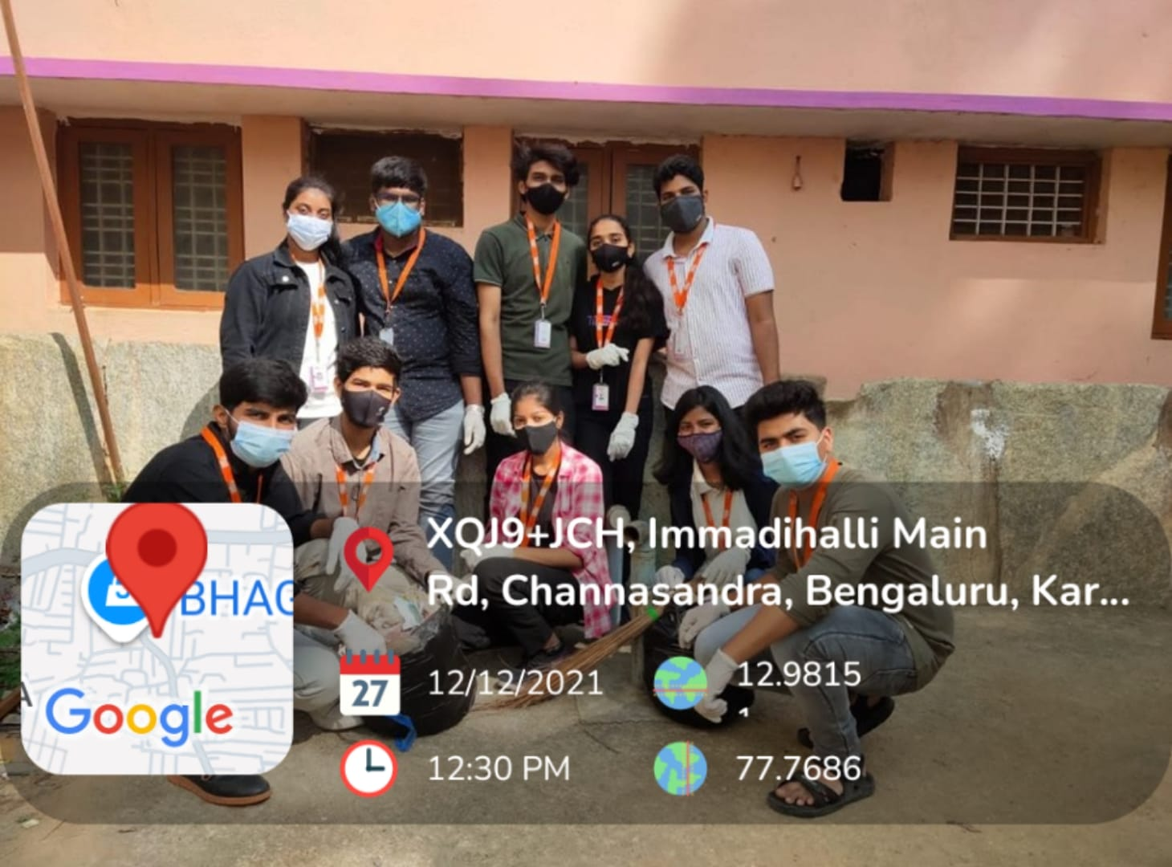

Each group was provided with safety gear like masks, gloves, brooms, dustpans, garbage bags, and cleaning cloths. My group was assigned to a classroom on the first floor. Our duties included:

• Sweeping the floors

• Removing cobwebs from the walls and ceilings

• Cleaning the windows and desks

• Wiping the blackboard

• Collecting and disposing of waste into designated garbage bags

Other groups cleaned the school ground, collecting dry leaves, wrappers, and other waste. After nearly two to three hours of work.

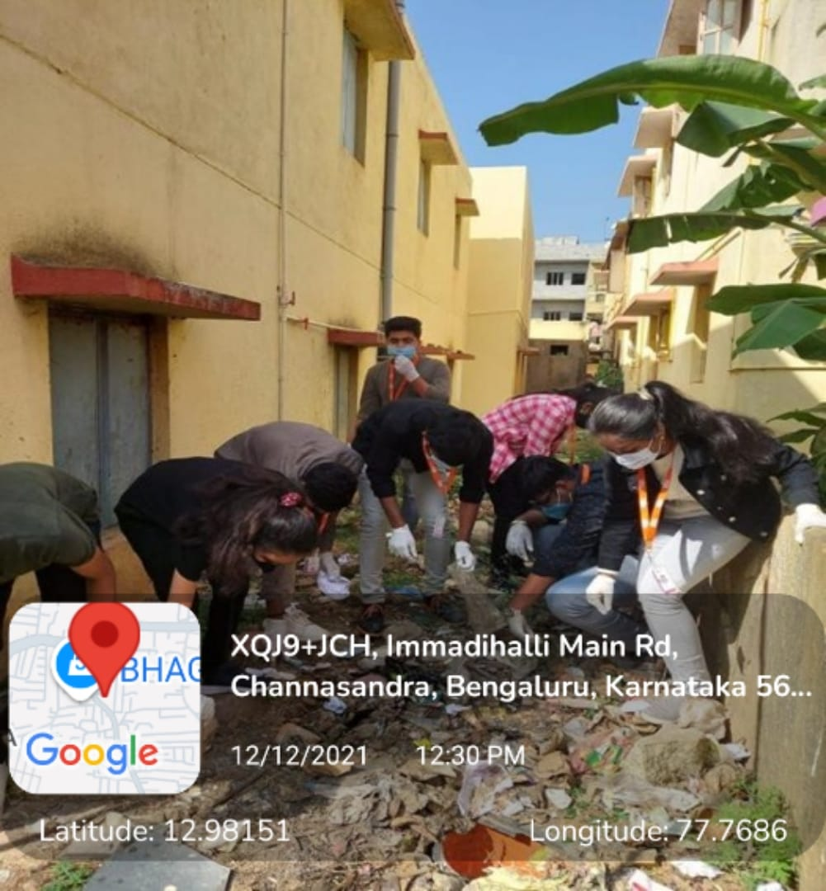

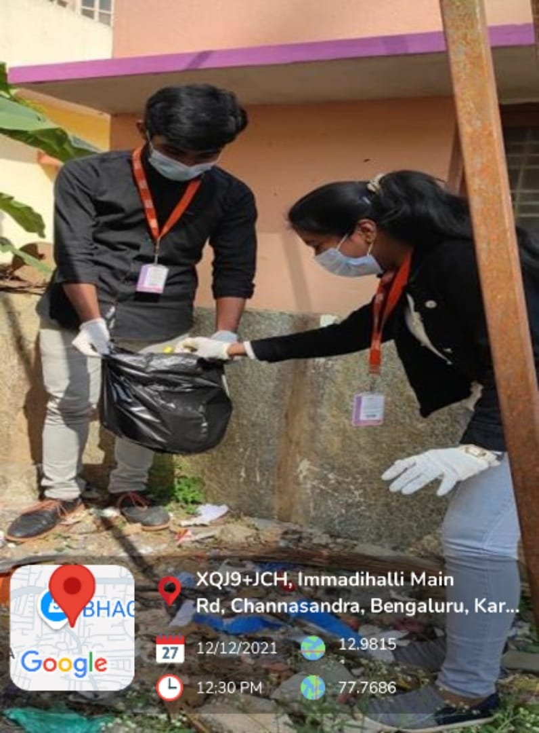

The **Winsome Activity members** then delivered a short speech on the importance of sanitation and responsible waste management. The event concluded with a group **cleanliness oath**, where we pledged to keep our surroundings, homes, and city clean.

1. **Key Learnings and Reflections**

Being part of this cleanliness drive was not just a fulfilling experience, but also an eye-opener. Some of the lessons I learned include:

* **Responsibility**: Keeping public spaces clean is not just the government's job it begins with us.
* **Teamwork**: Coordinated efforts can achieve meaningful results in a short time.
* **Respect** **for** **workers**: We developed a deeper respect for sanitation workers who perform these tasks daily.

The practical exposure to real-world problems of waste and hygiene made us realize the importance of sustained efforts toward a cleaner society

1. **Outcomes of the Activity**

As a result of this initiative:

* The school premises were visibly cleaner and more hygienic.
* Awareness regarding hygiene and cleanliness was successfully imparted to all participants.
* Students gained hands-on experience in contributing to a community-oriented mission.
* We helped promote the practice of waste segregation at source.
* Behavioral change was encouraged through direct involvement.

1. **Conclusion**

The Swachh Bharat Abhiyan activity left a lasting impression on everyone involved. Cleanliness is not a one-time task but a continuous process that requires individual and collective responsibility. This campaign taught us that small actions can lead to big transformations.

By following good sanitation practices, segregating waste, and being mindful of our environment, we can make our surroundings healthier and more sustainable. Schools, colleges, and institutions must continue organizing such drives to instill values of cleanliness and civic duty in the minds of students.

Let us all be the change we want to see in the world, starting with our own surroundings.

"Cleanliness is next to Godliness."

**ACTIVITY 2**

**SKILL DEVELOPMENT**

**Skill Development**

1. **Introduction**

Skill development is essential in today's digital world, playing a crucial role in holistic growth and career readiness. It bridges the gap between academic learning and practical application, equipping students with the necessary tools to succeed in modern industries. Technical and vocational education fosters problem-solving, creativity, and innovation—qualities vital for personal and national progress.

As part of our commitment to social responsibility and educational equity, we organized a technical education outreach program at a government primary school. This initiative aimed to spark curiosity and provide foundational exposure to technology and literature for young learners, particularly those from underserved backgrounds.

1. **Objective of the Activity**

The primary objectives of the skill development session were:

* Introducing basic technical concepts in a fun and understandable way.
* Encouraging early interest in technology, science, and literature.
* Engaging students through interactive teaching methods.
* Instilling a sense of curiosity and learning in young minds.
* Supporting and uplifting local government school education through voluntary outreach.

1. **Description of the Activity**

The session was conducted at Government Higher Primary School, Channasandra, Bengaluru. We arrived at 9:00 AM, met with the faculty, and coordinated the schedule. Students from 2nd and 3rd standard were gathered into classrooms for the lessons.

The interactive sessions included:

* Basic Kannada literature reading and storytelling.
* Teaching Kannada poems using visual and vocal expression.
* Using blackboards and physical storybooks to make learning immersive.
* Encouraging students to repeat and recite lines for better pronunciation and understanding.

By incorporating storytelling and rhythmic poetry, we ensured engagement and participation. The students displayed great enthusiasm, despite limited resources in their learning environment.

The session concluded with a discussion where students answered questions related to the poems and stories. Their responses showed active comprehension, making the experience fulfilling. We also shared informal feedback with teachers to help them continue engaging teaching methods.

1. **Key Learnings and Reflections**

The experience of teaching young students brought several insights:

- Empathy and Patience: Teaching required clarity, patience, and an understanding approach.

- Communication Skills: Simplifying concepts in the regional language improved communication abilities.

- Social Responsibility: The importance of contributing time and effort to grassroots education.

- Educational Gaps: Recognizing the limited resources in government schools and the need for additional support.

Despite their young age, the students grasped concepts quickly, showcasing their immense potential when given the right guidance and opportunities.

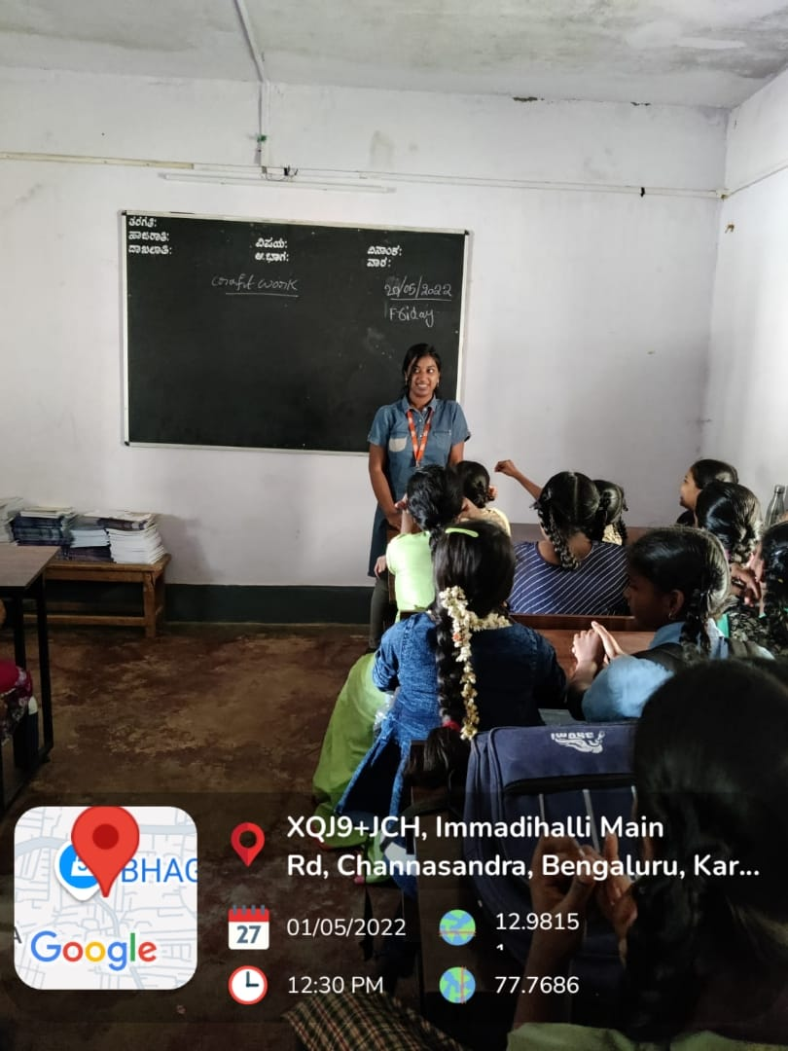 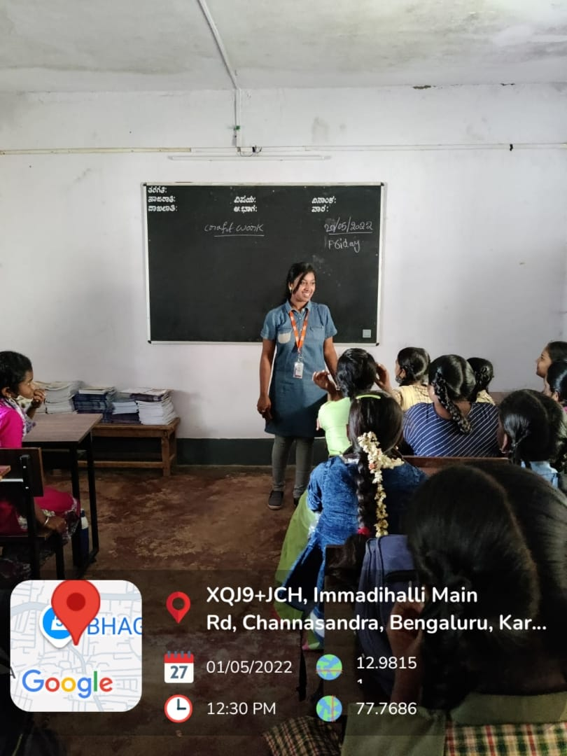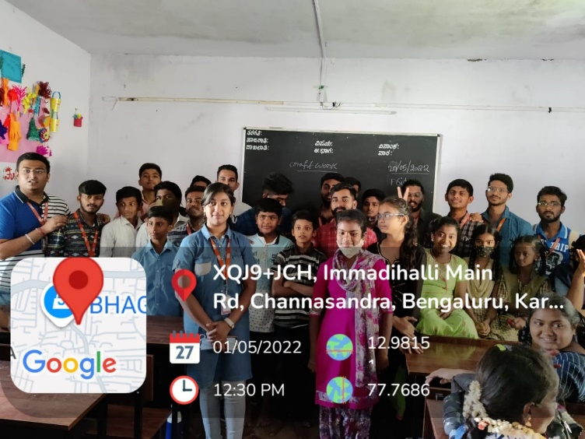

**5. Outcomes of the Activity**

Key outcomes observed during and after the session:

* Increased student interest in learning Kannada poems and stories.
* Improved confidence among children in reciting aloud in front of peers.
* Strengthened bonds between volunteers and the local community.
* A sense of fulfillment and teamwork among our team members.
* Initiated plans for future visits and regular knowledge-sharing sessions.

Our engagement left a lasting impact on both the children and ourselves, highlighting the power of education to inspire and transform lives.

**6. Conclusion**

This technical education outreach was more than just a volunteer effort—it was a step toward creating equitable learning experiences for all. By teaching Kannada literature and poems to primary school students, we nurtured their love for learning and helped bridge the educational gap.

Grassroots initiatives like these are essential for inclusive growth and literacy development. Moving forward, we aim to organize more outreach programs and actively contribute to educational awareness and upliftment. Let us continue to be torchbearers of knowledge and illuminate the path for the next generation.

"Teaching is the one profession that creates all other professions."

**ACTIVITY 3**

**TOURISM PROMOTION**

**Tourism Promotion Activity**

1. **Introduction**

Tourism is a vital sector that contributes significantly to the economy, cultural exchange, and community development. However, many potential tourists are unaware of the hidden gems and unique experiences that various destinations offer. Tourism promotion activities aim to bridge this gap by highlighting the attractions, culture, and hospitality of a region, encouraging more visitors to explore and enjoy these destinations.

**2. Objective of the Activity**

The tourism promotion campaign was carried out with the following key objectives:

* To highlight and promote the unique attractions and cultural heritage of the region.
* To increase awareness and interest among potential tourists.
* To support local businesses and boost the local economy.
* To foster a sense of pride and ownership among residents.
* To encourage sustainable and responsible tourism practices.

1. **Description of the Activity**

The activity took place near Dodda Hosakote Lake, Hosakote Taluk. Prior to the campaign, we held team discussions to plan logistics, gather resources, and ensure the effectiveness of our promotional efforts.

Our team collaborated to:

* Create engaging content such as videos, blogs, and social media posts showcasing local attractions.
* Partner with local influencers and travel bloggers to reach a wider audience.
* Organize events and tours to highlight key tourist spots.
* Distribute promotional materials like brochures and flyers.
* Engage with local businesses to offer special deals and packages for tourists.

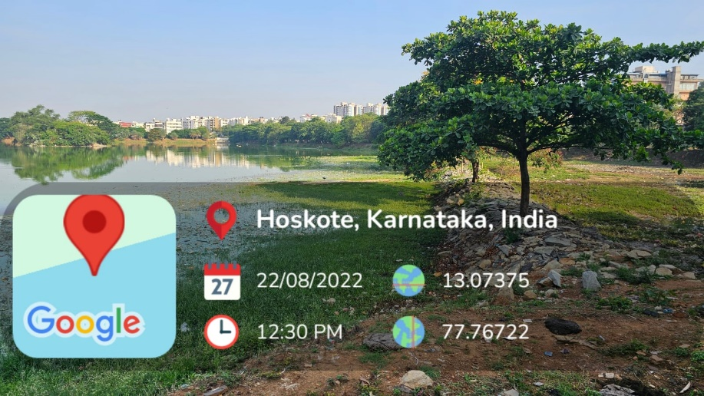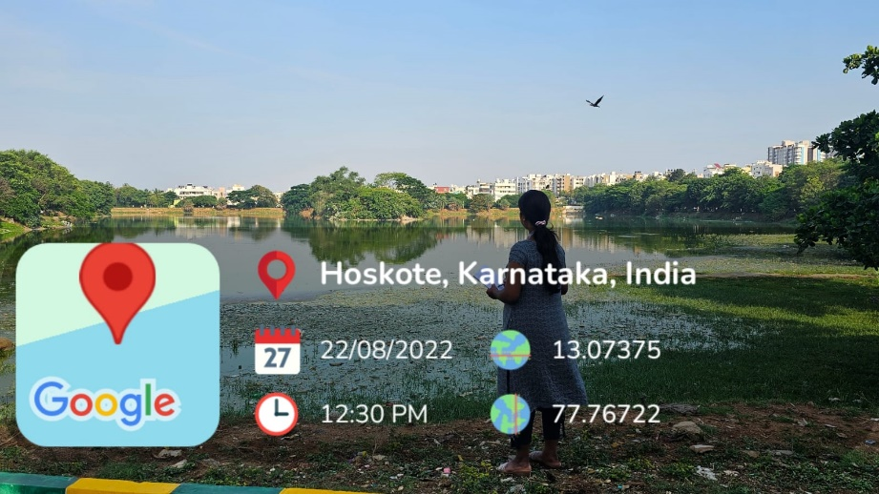

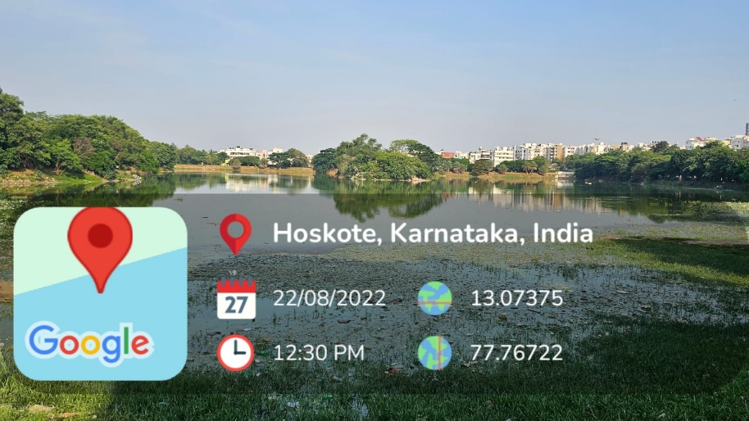

We promoted the region by leveraging various channels, including social media, local media, and travel websites. At each event, we interacted with participants, shared information about the attractions, and encouraged responsible tourism practices.

Apart from promotional content, we also organized interactive sessions where locals shared their stories and experiences, adding a personal touch to the campaign.

1. **Key Learnings and Reflections**

The tourism promotion campaign provided us with valuable insights beyond what any classroom could offer. Our key takeaways included:

* Community Engagement: Involving locals in the campaign created a sense of pride and ownership.
* Effective Communication: The success of the campaign was a direct result of clear and engaging communication strategies.
* Cultural Appreciation: The experience deepened our appreciation for the local culture and heritage.
* Resource Management: It taught us the importance of planning, budgeting, and collaboration in executing such campaigns.

1. **Outcomes of the Activity**

This campaign led to several positive outcomes, including:

* Increased awareness and interest in the region among potential tourists.
* Boosted local economy through increased tourist visits and spending.
* Strengthened relationships between local businesses and the community.
* Encouraged more residents to participate in and support tourism activities.
* Laid the foundation for future tourism promotion efforts.

The campaign not only attracted visitors but also fostered a sense of community and pride among residents.

1. **Conclusion**

Our tourism promotion campaign was a reminder that even a single effort can spark interest and bring positive change to a community. It encouraged us to be more mindful of our cultural heritage and to share it with the world. Promoting tourism instills pride, gratitude, and a renewed sense of purpose.

We hope to continue these efforts regularly and inspire others to contribute towards a vibrant and welcoming tourism industry.

“Travel makes one modest. You see what a tiny place you occupy in the world.”

– Gustave Flaubert

**ACTIVITY 4**

**WOMEN EMPOWERMENT**

**Menstruation and Hygiene Awareness Survey**

1. **Introduction**

Menstruation is a natural biological process, yet it remains surrounded by stigma and misinformation in many communities. Promoting awareness about menstruation and hygiene is crucial for ensuring the health and well-being of individuals who menstruate. Our survey aimed to gather insights on current knowledge, attitudes, and practices related to menstruation and hygiene, and to use this information to drive educational initiatives and support.

In line with this vision, our team conducted a survey to understand the challenges faced by individuals in our community and to promote better menstrual hygiene practices. This activity was not only an effort to educate but also a reminder of the collective power we hold to bring positive change to society.

1. **Objective of the Activity**

The survey was carried out with the following key objectives:

* To assess the level of awareness and knowledge about menstruation and hygiene.
* To identify common misconceptions and barriers to proper menstrual hygiene.
* To promote the importance of menstrual health and hygiene practices.
* To support educational initiatives aimed at improving menstrual hygiene.
* To foster a sense of community engagement and support.

1. **Description of the Activity**

The survey took place in Government Higher Primary School, Khazimakan Hosakote Town. Prior to conducting the survey, we held team discussions to plan logistics, design the questionnaire, and ensure the confidentiality and sensitivity of the responses.

Our team collaborated to:

* Develop a comprehensive questionnaire covering various aspects of menstruation and hygiene.
* Distribute the survey through online platforms and physical forms.
* Ensure anonymity and confidentiality of the respondents.

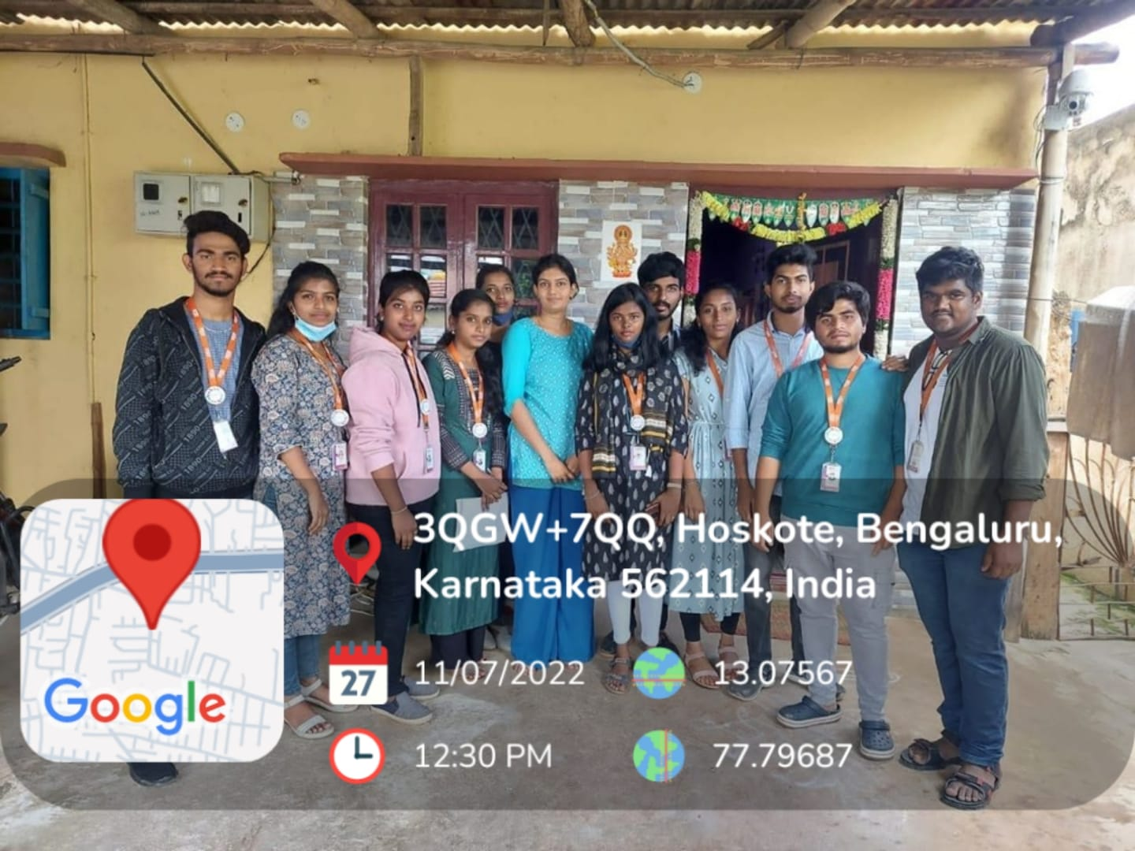

We conducted the survey by reaching out to individuals in schools, colleges, and local communities. At each location, we explained the purpose of the survey, encouraged honest responses, and provided information on menstrual hygiene practices.

Apart from the survey, we also organized informational sessions where experts shared knowledge about menstrual health, hygiene products, and practices.

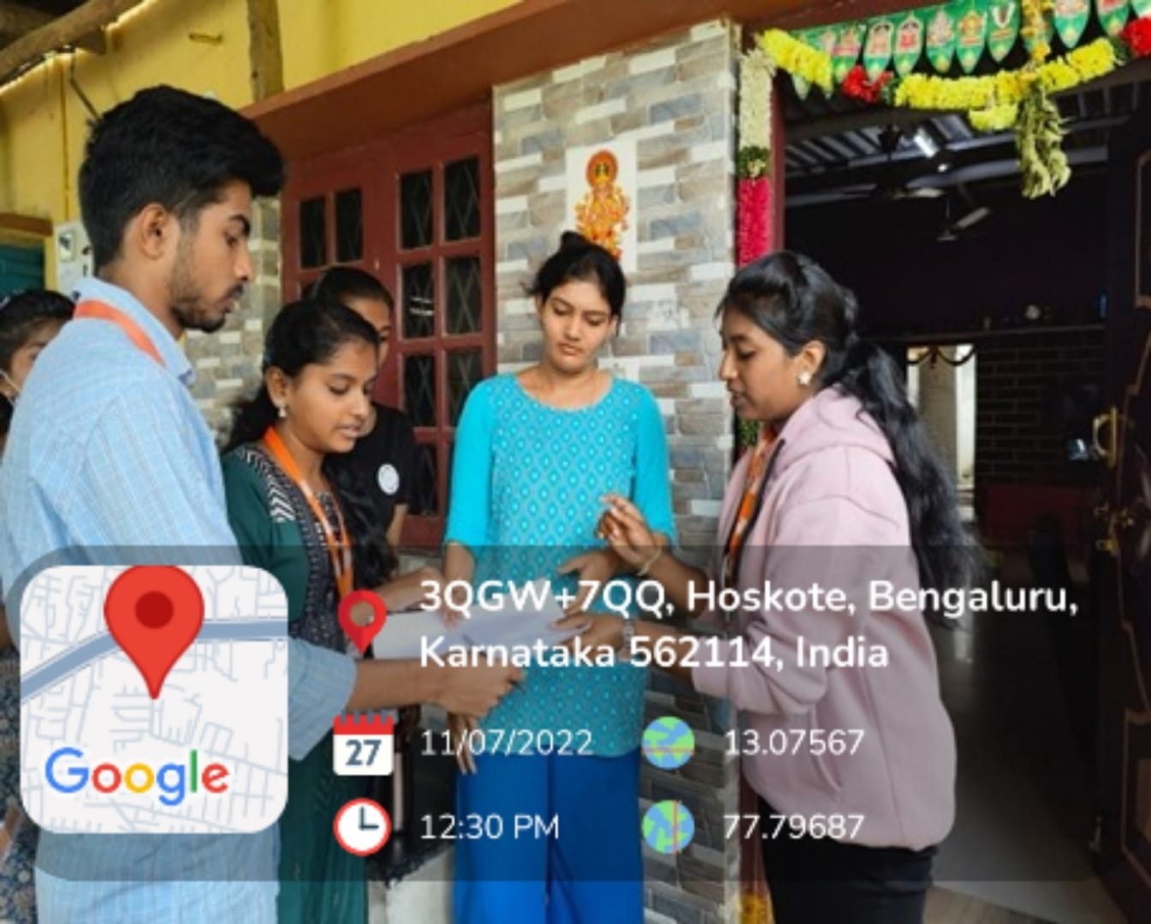

1. **Key Learnings and Reflections**

The survey provided us with valuable insights beyond what any classroom could offer. Our key takeaways included:

* Awareness Gaps: Identifying areas where knowledge about menstruation and hygiene is lacking.
* Community Engagement: Involving the community in the survey created a sense of support and openness.
* Educational Needs: Understanding the need for more comprehensive menstrual health education.
* Resource Management: It taught us the importance of planning, confidentiality, and sensitivity in conducting such surveys.

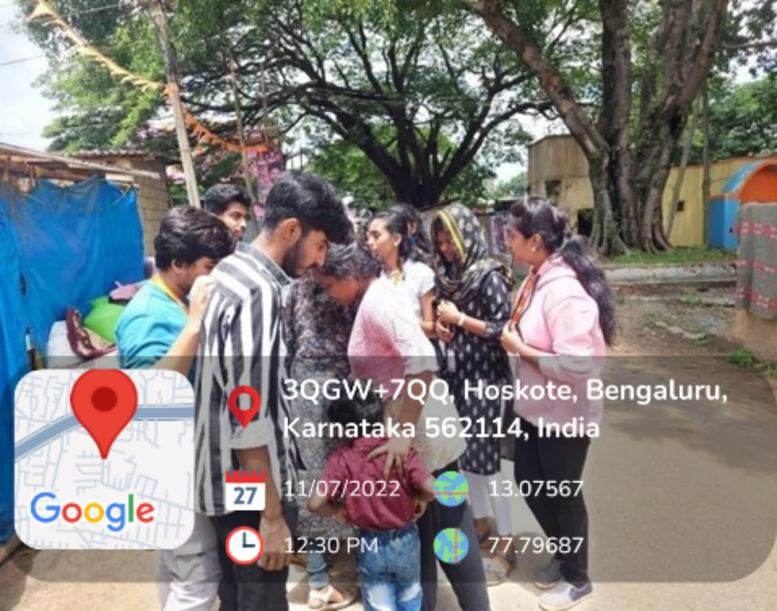

1. **Outcomes of the Activity**

This survey led to several positive outcomes, including:

* Increased awareness and understanding of menstruation and hygiene among participants.
* Identification of common misconceptions and barriers to proper menstrual hygiene.
* Encouraged more peers to participate in and support menstrual health initiatives.
* Strengthened relationships between educational institutions and the community.
* Laid the foundation for future educational and support activities.

The survey not only gathered valuable data but also fostered a sense of community and support among participants.

1. **Conclusion**

Our menstruation and hygiene awareness survey was a reminder that even a single effort can spark change and bring positive impact to a community. It encouraged us to be more mindful of menstrual health and to share knowledge with others. Promoting menstrual hygiene instills confidence, health, and a renewed sense of purpose.

We hope to continue these efforts regularly and inspire others to contribute towards a healthier and more informed society.

“Empowerment begins with education.”

**ACTIVITY 5**

**DISTRIBUTION OF ESSENTIALS**

**Distribution of Essentials Activity**

1. **Introduction**

Access to basic essentials is a fundamental need, yet many individuals and families face challenges in obtaining them due to various socio-economic factors. Distributing essentials to those in need helps bridge this gap and supports underprivileged communities. Our team organized an essentials distribution drive at Visveshwarapura PU College to provide necessary items to students and local residents, promoting well-being and community support.

In line with this vision, our team participated in this drive to ensure that everyone has access to basic necessities and to spread awareness about the importance of community support and solidarity.

1. **Objective of the Activity**

The essentials distribution drive was carried out with the following key objectives:

To provide necessary items such as food, clothing, and hygiene products to those in need.

* To promote the values of sharing, empathy, and social responsibility among students.
* To raise awareness about the importance of supporting underprivileged communities.
* To foster a sense of community engagement and volunteerism.
* To support a sustainable and inclusive approach to community welfare.

1. **Description of the Activity**

The activity took place at Visveshwarapura PU College. Prior to the distribution, we held team discussions to plan logistics, gather resources, and ensure the safety and hygiene of the items being distributed.

Our team collaborated to:

* Collect and pack essentials such as food items, clothing, and hygiene products.
* Organize transportation and packaging of the essentials.
* Maintain hygiene protocols like hand gloves, masks, and sanitizers.
* Identify and approach individuals and families who were in need.

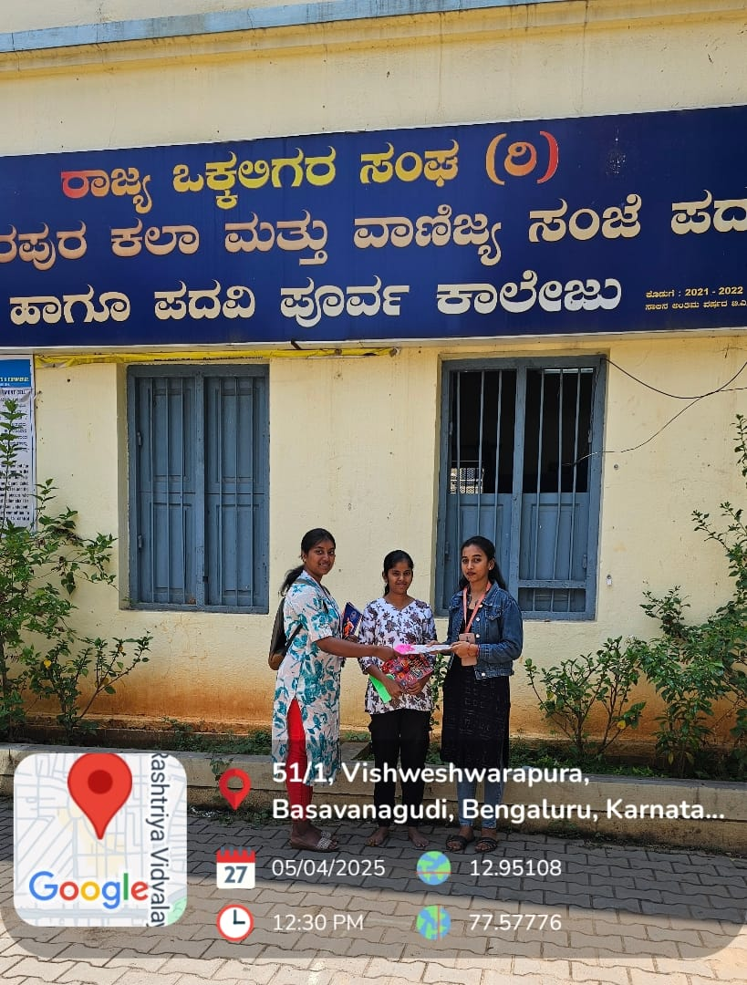

We distributed the essentials by personally visiting the college and nearby areas where students and local residents reside. At each stop, we interacted with recipients, asked about their well-being, and encouraged hygienic practices.

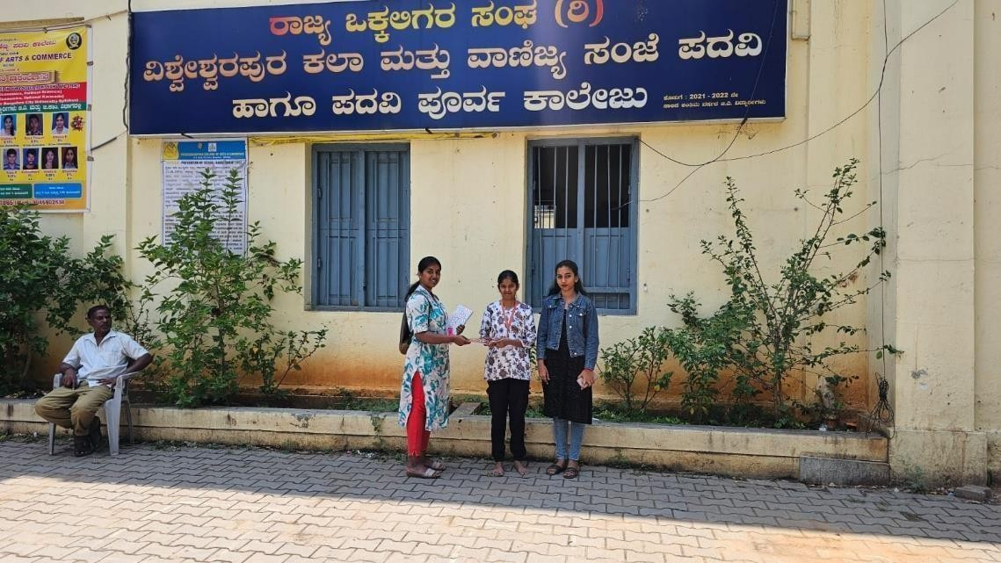

Apart from essentials, we also handed out informational pamphlets on hygiene and health practices. We ensured everyone received their share with dignity, kindness, and without crowding or rush.

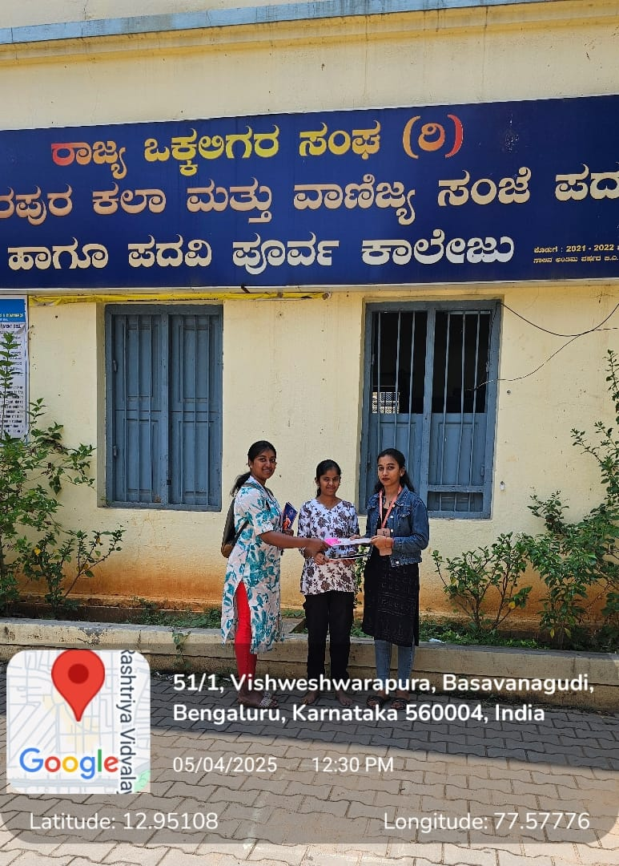

1. **Key Learnings and Reflections**

The essentials distribution drive provided us with powerful insights beyond what any classroom could offer. Our key takeaways included:

* Empathy in Action: Seeing gratitude in the eyes of recipients reinforced our understanding of privilege and compassion.
* Teamwork and Coordination: The success of the drive was a direct result of seamless collaboration and communication among volunteers.
* Awareness of Ground Realities: The experience exposed us to the living conditions of many families and inspired us to keep contributing in small yet impactful ways.
* Resource Management: It taught us the importance of budgeting, procurement, hygiene, and time management in planning such outreach events.

1. **Outcomes of the Activity**

This drive led to several positive outcomes, including:

* Distribution of essential items to underprivileged individuals and families.
* Increased student awareness about the importance of community support and welfare.
* Encouraged more peers to volunteer and initiate similar outreach efforts.
* Strengthened the bond between students and the local community.
* Built a strong foundation for continuing such community engagement activities in the future.

The essentials distribution not only provided necessary items but also filled hearts with warmth, respect, and a sense of togetherness.

**6. Conclusion**

Our essentials distribution drive was a reminder that even a single act of service can spark hope in someone’s life. It encouraged us to be more mindful of our privileges and to never take them for granted. Giving back to the community instills humility, gratitude, and a renewed sense of purpose.

We hope to continue these efforts regularly and inspire others to contribute towards a supportive and compassionate society.

“Service to others is the rent you pay for your room here on Earth.” – Muhammad Ali

**ACTIVITY 6**

**100% DIGITALIZE MONEY TRANSACTION**

**Facilitating 100% Digitized Money Transactions Activity**

1. **Introduction**

In today's digital age, the shift towards cashless transactions is essential for enhancing convenience, security, and efficiency. Facilitating 100% digitized money transactions helps in promoting financial inclusion, reducing the risks associated with cash handling, and fostering a tech-savvy community. Our team organized an initiative at Visveshwarapura PU College and local provision stores to promote and implement digital payment methods among students, staff, and local businesses.

In line with this vision, our team participated in this initiative to ensure that everyone at the college and local provision stores is equipped with the knowledge and tools to perform digital transactions seamlessly.

1. **Objective of the Activity**

The digitized money transactions initiative was carried out with the following key objectives:

* To educate students, staff, and local business owners about the benefits and methods of digital transactions.
* To promote the use of digital payment platforms for all financial activities within the college and local provision stores.
* To ensure a secure and efficient transaction environment.
* To support the government's vision of a Digital India.
* To foster a sense of technological adaptability and financial literacy among students and the local community.

1. **Description of the Activity**

The activity took place at Visveshwarapura PU College and surrounding local provision stores. Prior to the implementation, we held team discussions to plan logistics, gather resources, and ensure the effectiveness of our educational efforts.

Our team collaborated to:

* Conduct workshops and training sessions on various digital payment platforms such as UPI, mobile wallets, and online banking.
* Distribute informational materials like brochures and guides on how to use digital payment methods.
* Set up digital payment systems in the college canteen, library, and local provision stores.
* Ensure the availability of necessary infrastructure like internet connectivity and digital devices.
* 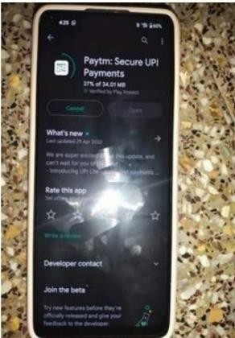Provide one-on-one assistance to students, staff, and local business owners to address any queries or issues.

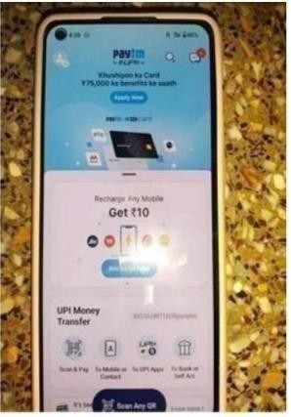

We promoted the use of digital transactions by organizing interactive sessions where experts demonstrated the use of different digital payment platforms. At each session, we encouraged participants to practice using these platforms and provided hands-on support.

Apart from workshops, we also set up help desks where students, staff, and local business owners could get real-time assistance with digital transactions

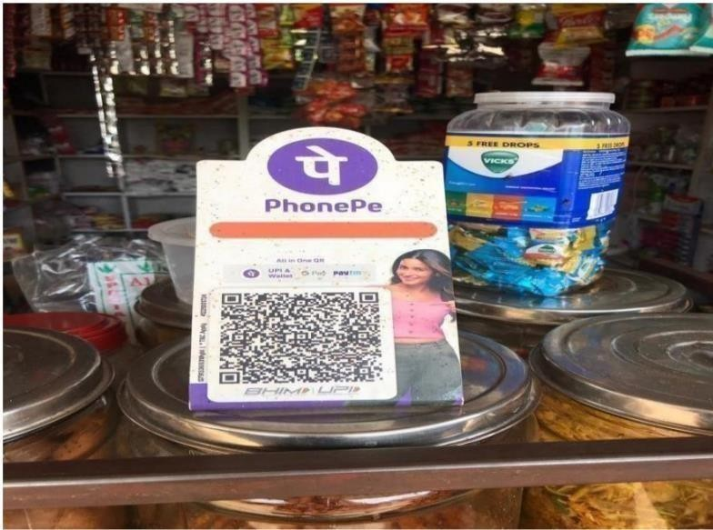

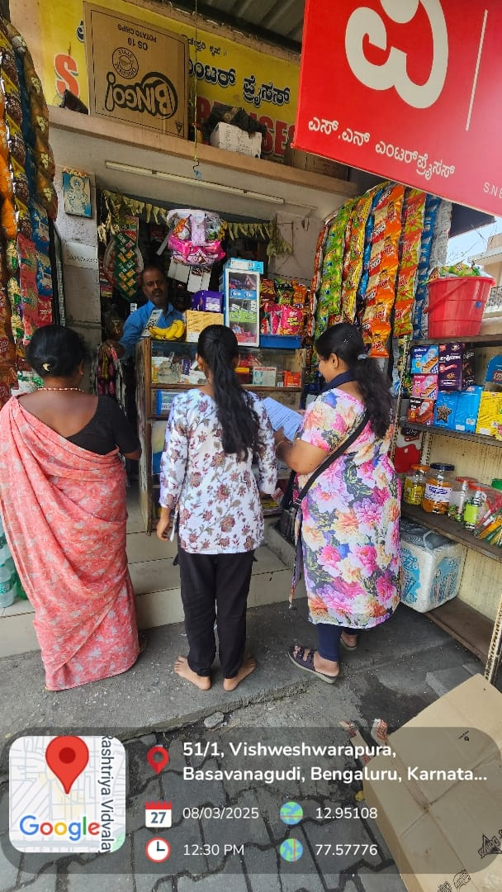 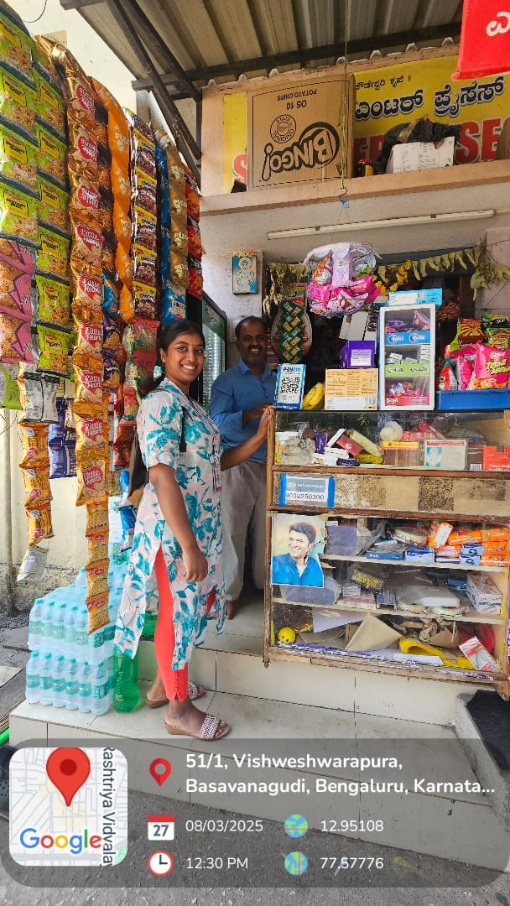

1. **Key Learnings and Reflections**

The digitized money transactions initiative provided us with valuable insights beyond what any classroom could offer. Our key takeaways included:

* Technological Adaptability: Understanding the importance of adapting to new technologies for financial transactions.
* Community Engagement: Involving the college and local community in the initiative created a sense of support and openness.
* Educational Needs: Recognizing the need for continuous education on digital literacy and financial security.
* Resource Management: It taught us the importance of planning, infrastructure setup, and continuous support in implementing such initiatives.

1. **Outcomes of the Activity**

This initiative led to several positive outcomes, including:

* Increased awareness and usage of digital payment methods among students, staff, and local business owners.
* Enhanced financial literacy and security within the college and local community.
* Encouraged more peers and local businesses to adopt and promote digital transactions.
* Strengthened the technological infrastructure of the college and local provision stores.
* Laid the foundation for future digital literacy and financial inclusion efforts.

1. **Conclusion**

Our digitized money transactions initiative was a reminder that even a single effort can spark change and bring positive impact to a community. It encouraged us to be more mindful of technological advancements and to share knowledge with others. Promoting digital transactions instills confidence, security, and a renewed sense of purpose.

We hope to continue these efforts regularly and inspire others to contribute towards a digitally empowered and financially inclusive society.

“Technology is best when it brings people together.” – Matt Mullenweg

.